System installation and guideline

# Source code

## 1.1 front end

Front end is based on HTML and JavaScript, no third party framework is used.

## 1.2 backend

Backend is Spring boot Maven project running with JDK 1.8, including Spring framework, Spring MVC and Spring Data JPA. If you want to run the application, refer below snapshot:

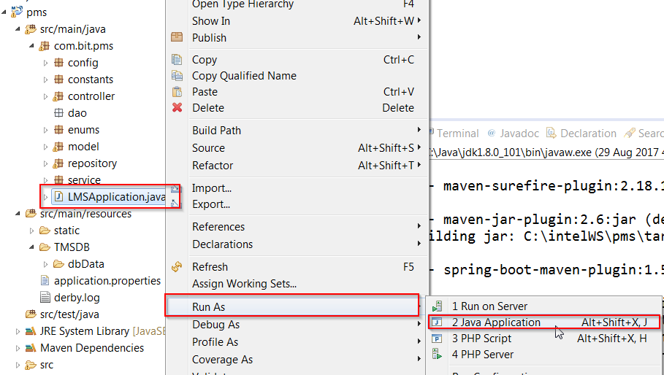

1) configuration file

application.properties is the main configuration file of Spring boot project, currently we create a DB called “px”, change this name if you create a different one.

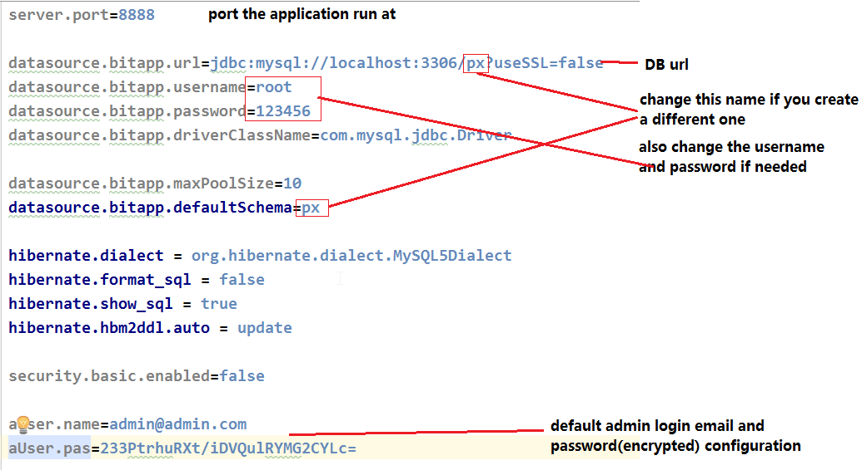

# Pages instruction

## 2.1 login and student home page

Index page is default to login page as below:

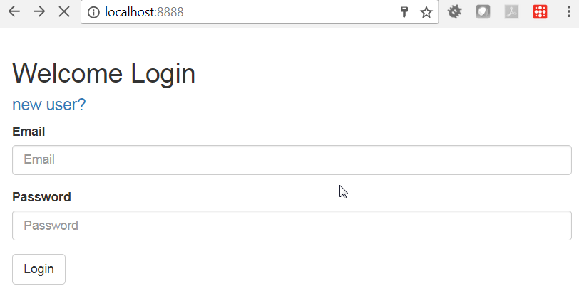

If you login the first name, click “new user” to register as below:

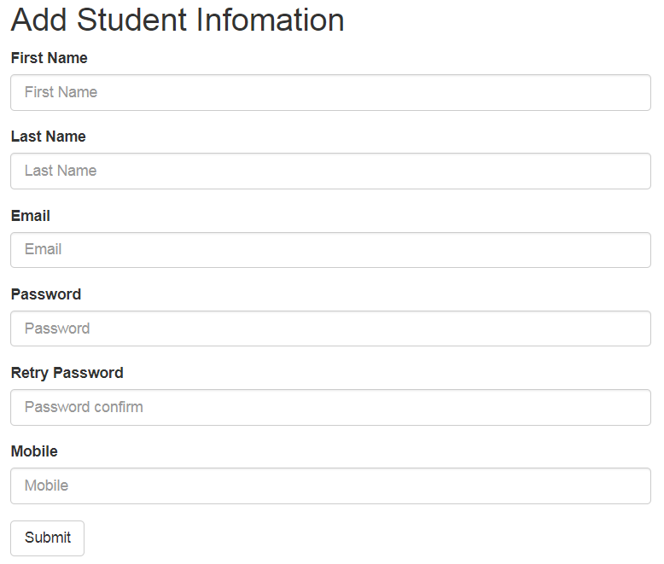

Filling in all inputs and click “Submit” to save the user to DB, if success, you will be relocated to index page to login.

On the login page input your email and password will go to welcome page which is currently your profile information as below:

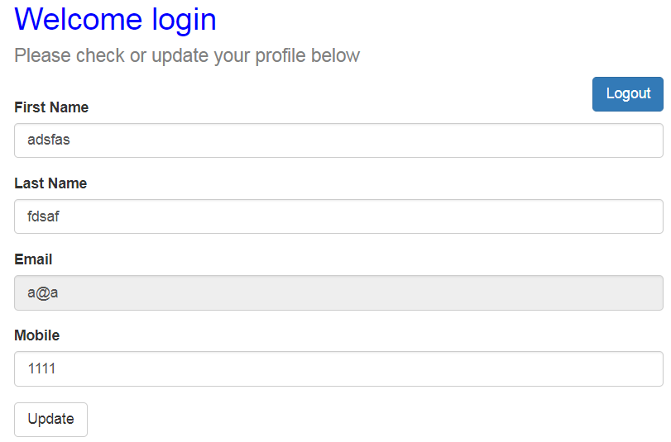

Modify your information and click “Update” button to change your infor, or click “Logout” to log out and return to login page.

## 2.2 admin page

If you login as [admin@admin.com](mailto:admin@admin.com) with the password “admin”

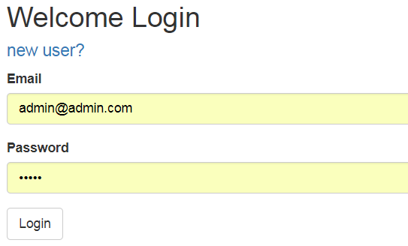

You will go to the admin page as below:

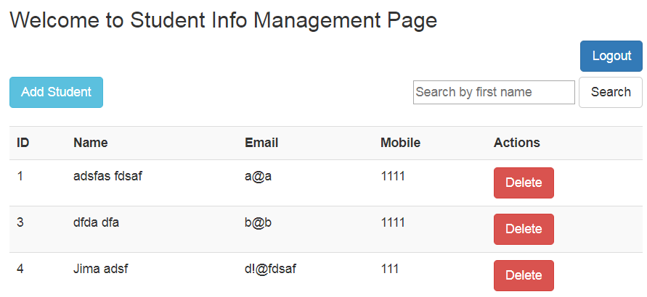

In this admin page, you can add a new student, delete an existing one, or search a student with first name.

**Week 8 solution:**

1) Security: we will introduce and use Spring Security as our security solution to secure the login as well as all rest APIs.

2) Restful web service: We will use Spring MVC to publish RESTful APIs